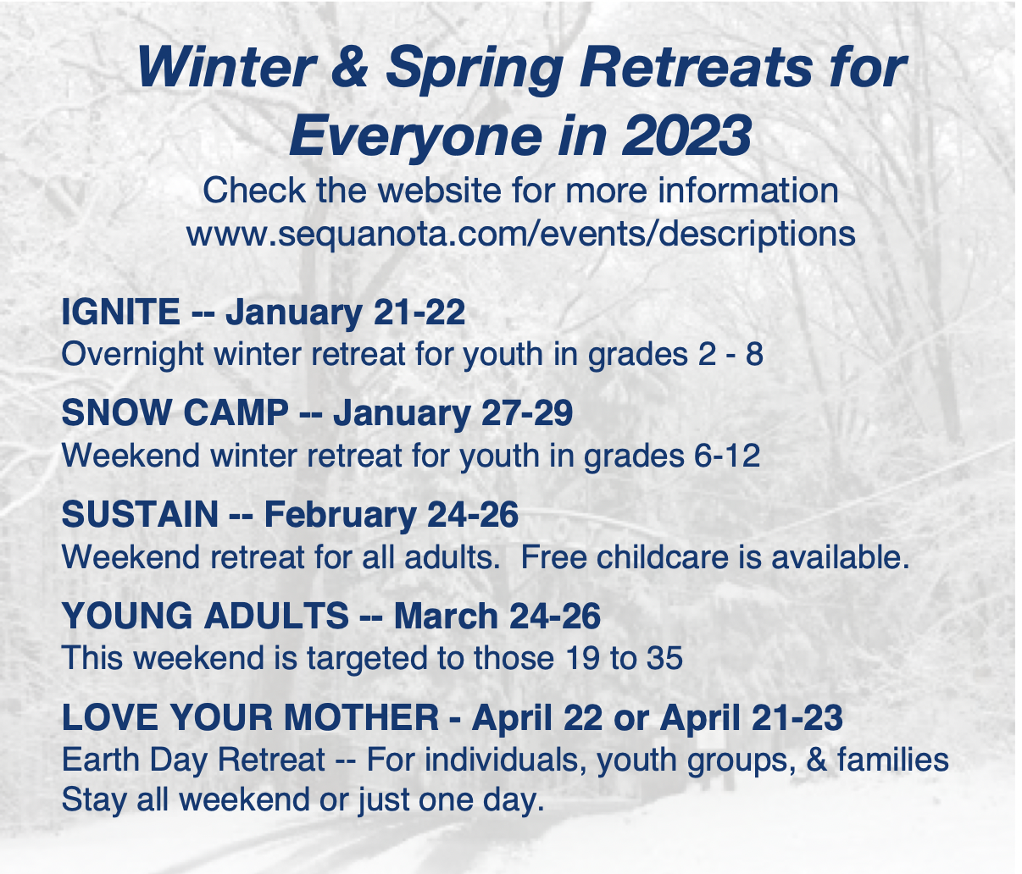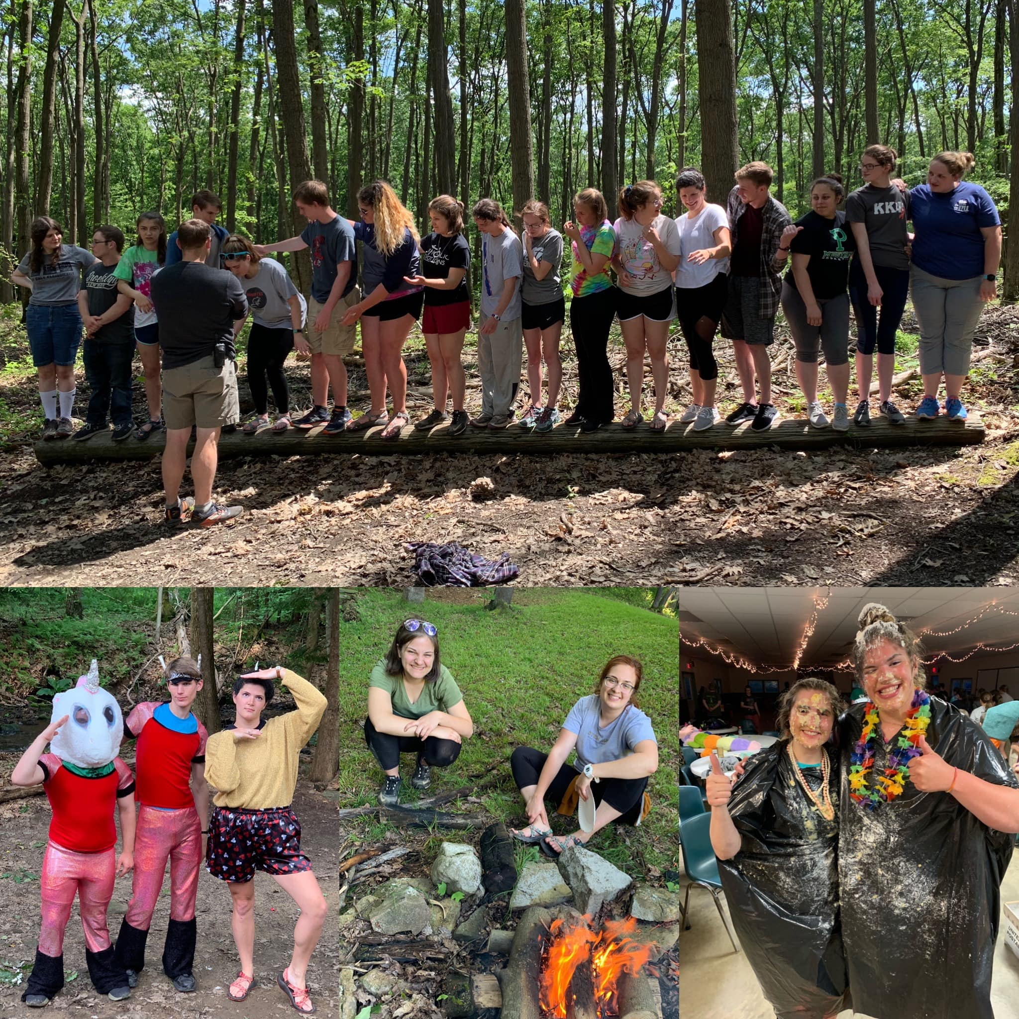

We believe God plants the seeds of faith in every life. Any good gardener knows that those seeds need tending if the seed is to produce vegetables or fruit. Faith needs to be tended. Our goal is to provide a weekly dose of tending for our faith and others, who might choose to join us as we live into the way of Jesus.

New episodes released on Mondays. Join the discussion on Facebook and Instagram.

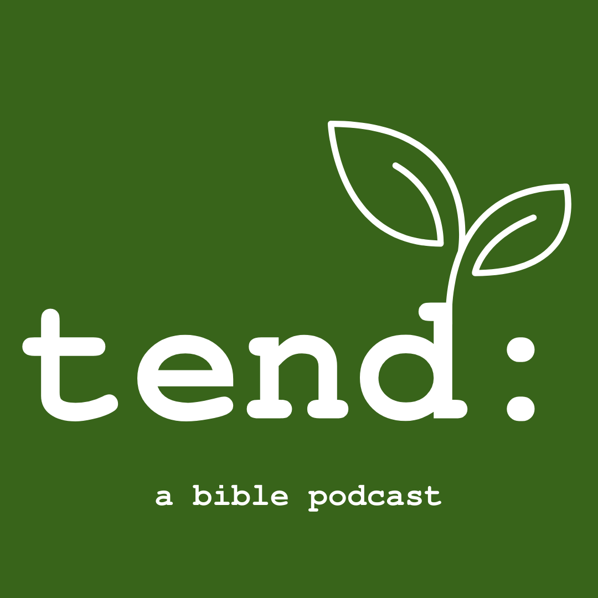

**tend: a bible podcast is now available**

Primary reading - the Gospel of Matthew; If you are are seeking a deeper read you can include “Free of Charge: Giving and Forgiving in a Culture Stripped of Grace” by Miroslav Volf. We will meet weekly on Zoom to engage the God who loves us in Bible study and discussion. All are welcome! The Zoom link will be available on Sequanota’s website.

**Lenten Bible Study on Zoom**

Dates: Feb 28, March 7, 14, 21, 28, April 4

Jess shares: “Sequanota has taught me how to be a good leader, how to interact with people of all ages, and have confidence in all that I do. Camp has given me a place that I know I will always be welcomed at.”

**Do you know of a young adult that you think could make an impact this summer at Sequanota?**

Give Sequanota a chance this summer — we know camp helps our staff develop as a leader!

Apply at <https://sequanota.com/summer/staff/>

**Staff applications are open for Summer 2023!**

The future of any profession will have a foundation in working with other people. This is at the heart of what we do at camp. Staff work with people everyday! Whether it be communicating the daily schedule to the cabin group, working with other staff members to plan and lead an activity or creating an experience that campers will remember forever - staff will be getting first hand experience.

**CAMP SEQUANOTA: UPCOMING EVENTS**