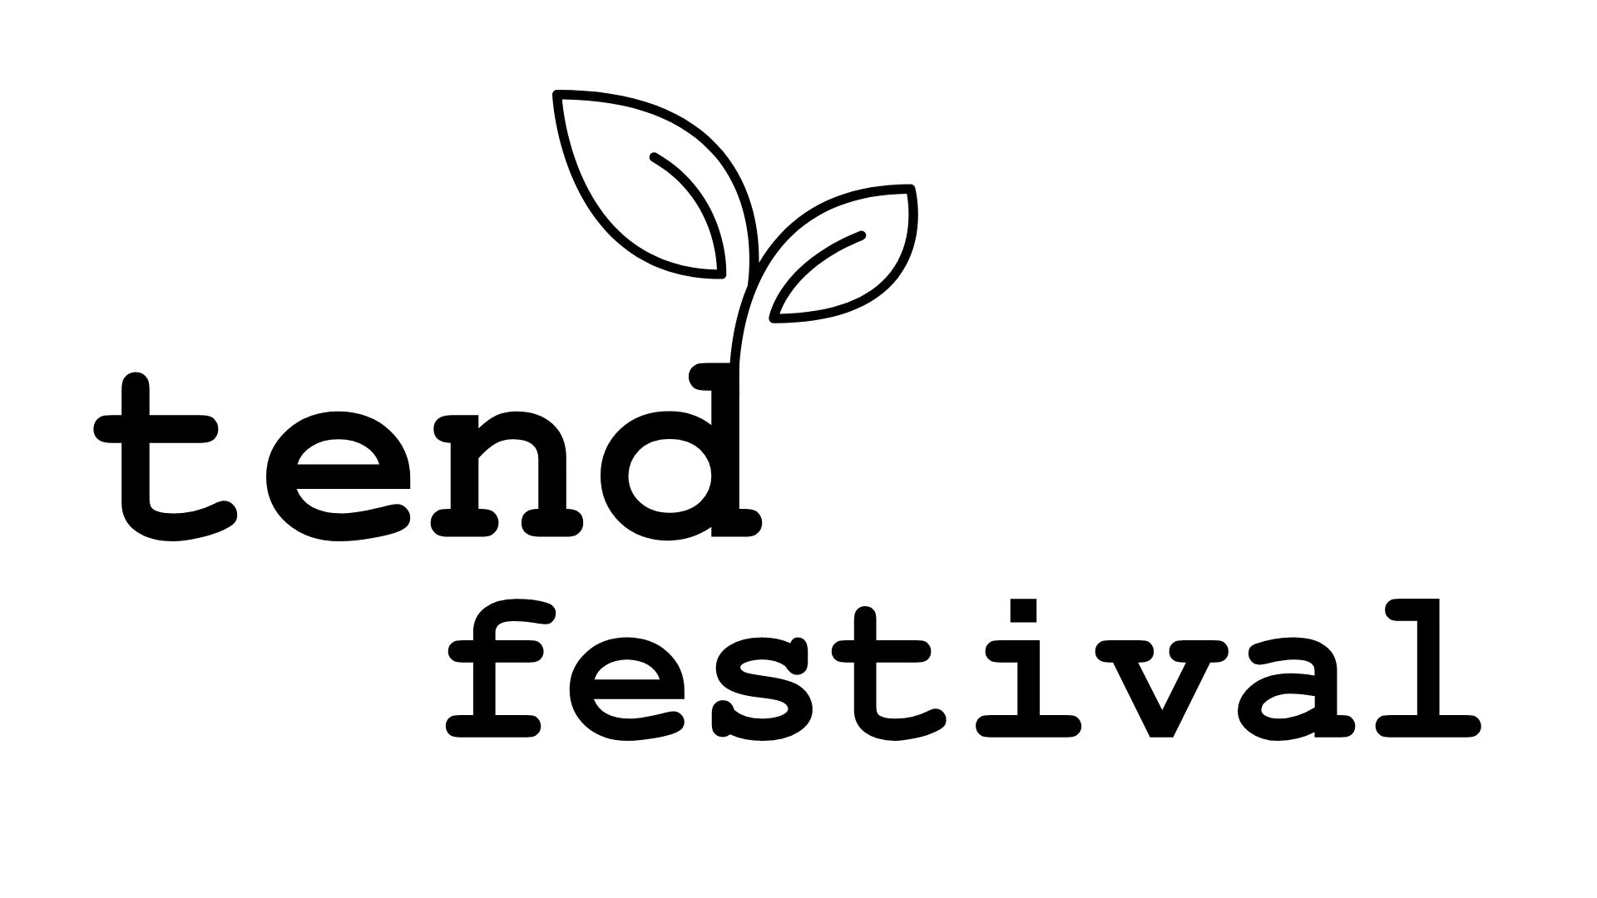

Connecting Christ, Creation & Community

As a church, we are at our best when we are together. The Tend Festival is four days of growing together as a greater community.

**Areas of faith-based learning:**

* Environment
* Devotional
* Economics, Justice & Advocacy
* Food & Health
* Practical Theology
* Music
* Arts & Media
* Open Space for discussion

[www.sequanota.com/tendfest](http://www.sequanota.com/tendfest)

Learn More

The Tend Festival is a unique new experience that is open to everyone. Come by yourself, bring your friends and family, or invite your whole church! The Tend Festival is a long weekend of growth and learning designed to bring God’s people closer together.

As a time of learning, Tend Festival offers different areas of learning. Each of our tents will have a different theme for the long weekend, teaching different faith-based lessons on topics ranging from the environment to social justice. These lessons will be taught by a wide variety of faith leaders with the main goal of helping you grow your faith in whatever area interests you most.

**Stretch your mind, connect with others**

June 20 - 23, 2024

Connecting Christ, Creation & Community

As a church, we are at our best when we are together. The Tend Festival is four days of growing together as a greater community.

**Areas of faith-based learning:**

* Environment
* Devotional
* Economics, Justice & Advocacy
* Food & Health
* Practical Theology
* Music
* Arts & Media
* Open Space for discussion

[www.sequanota.com/tendfest](http://www.sequanota.com/tendfest)

Learn More

**Stretch your mind, connect with others**

June 20 - 23, 2024

Sequanota Conference Center and Camp, Jennerstown, PA 15547

Sequanota Conference Center and Camp, Jennerstown, PA 15547

The Tend Festival is a unique new experience that is open to everyone. Come by yourself, bring your friends and family, or invite your whole church! The Tend Festival is a long weekend of growth and learning designed to bring God’s people closer together.

As a time of learning, Tend Festival offers different areas of learning. Each of our tents will have a different theme for the long weekend, teaching different faith-based lessons on topics ranging from the environment to social justice. These lessons will be taught by a wide variety of faith leaders with the main goal of helping you grow your faith in whatever area interests you most.